*Note 1*: I have copied most of this from “msguides.com”. Visit there for more good stuff 😀.

*Note 2*: This method is fully legal, but it depends on the number of remaining activations on a MAK.

**Directions**

1. Open the run box with “windows+r”. Type in “slui.exe” to open the activation wizard. Assuming if this is your first time opening it, you will be prompted with another window to “Activate Online”. Click on that. If this is your second time plus etc, skip to step 2.   
   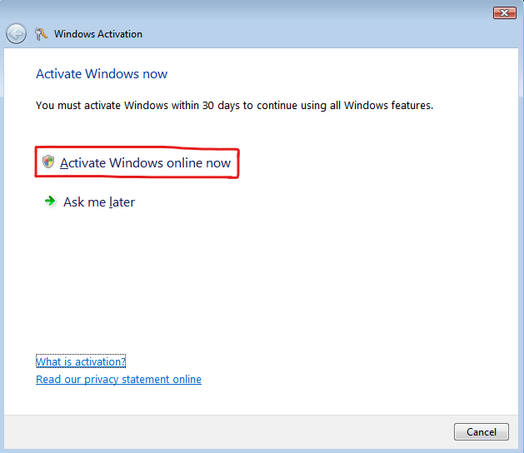
2. Assuming this is your second time, you will be asked to re-enter a key, assuming you didn’t already use the same key. If you did already, skip to ***step X.*** So, first, allow the activation wizard administrator permissions when it prompts such. Now, assuming you either entered a different key than the one supplied here, or it’s your first time entering a key, type in the product key present in “Key image.png”, retrieved from the link supplied in “Key source courtsey of 'MoTheDestroyer'.url”, courtesy of Reddit user u/MoTheDestroyer into the box and click next.   
     
   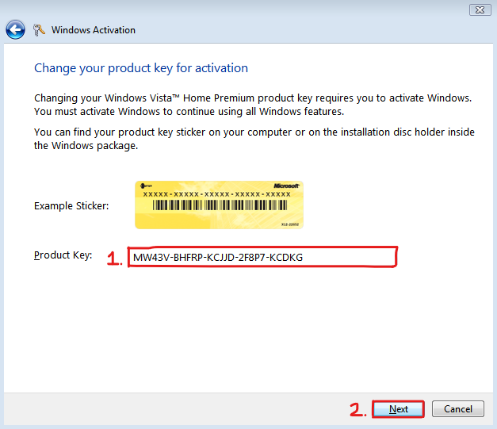
3. Now, wait for windows to check the key. After checking, you should get an error with the code 0x80072F8F. In that screen, there should be the option of “Show me other ways to activate”. Click on that.  
   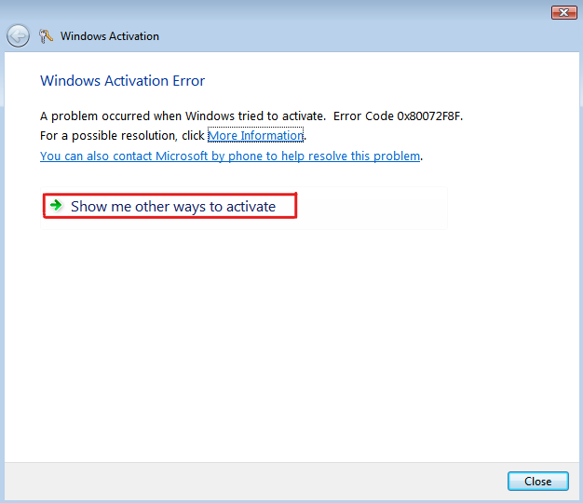
4. Now, click on “Use the automated phone system”.  
   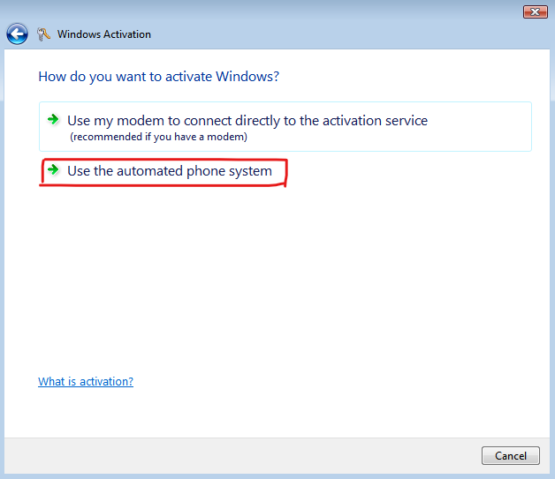
5. Next, you will be prompted with location. This doesn’t matter, so just go with the default and click on next.  
   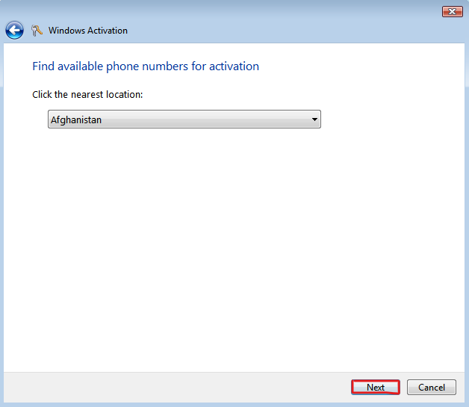
6. This screen should appear:  
   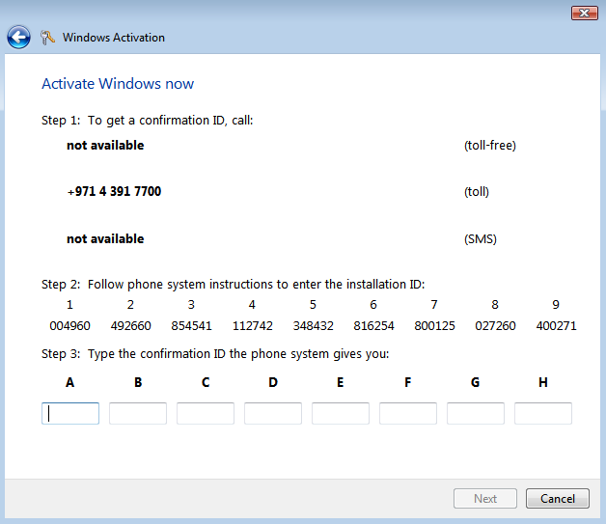  
   Once you arrive on that screen, click on the .url file provided in the activation folder I have supplied, named “Microsoft Self Service for mobile; working 2020.url”. This should bring you to “microsoft.gointeract.io”. In the screen, click on the option “6 Digits”…  
   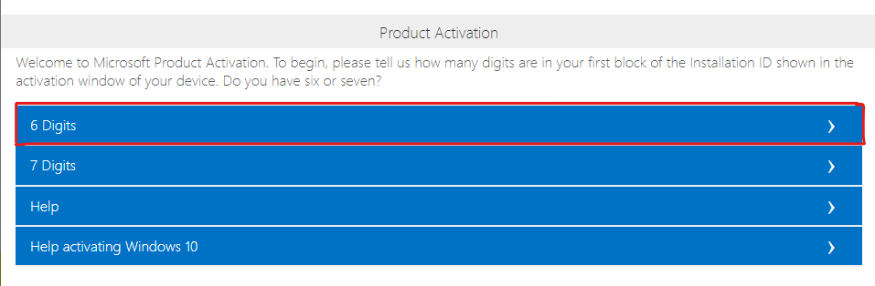  
   …and then enter the numbers supplied in the Vista Activation Wizard(note that this will be different every time you do this, so don’t use the ones here, but the ones generated for your computer). After you are done, click submit.  
   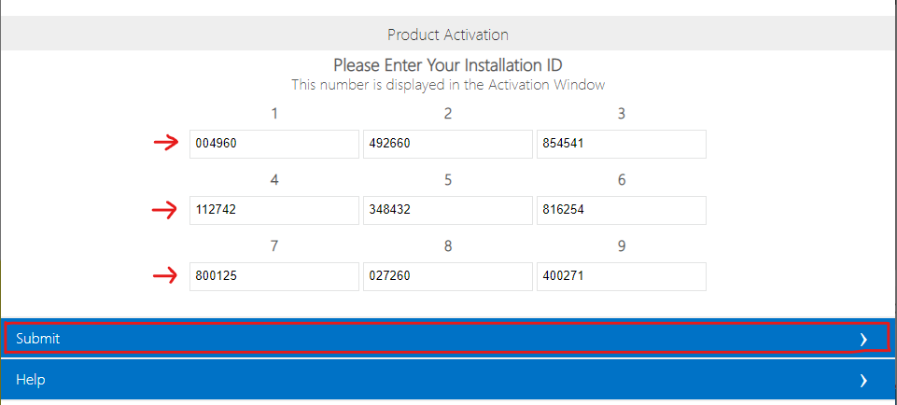
7. Now, the site will ask you “How many computer have you installed this copy of software?”. Enter “1” and press on submit. ***DO NOT*** *put a number greater than 1* 🤣.  
   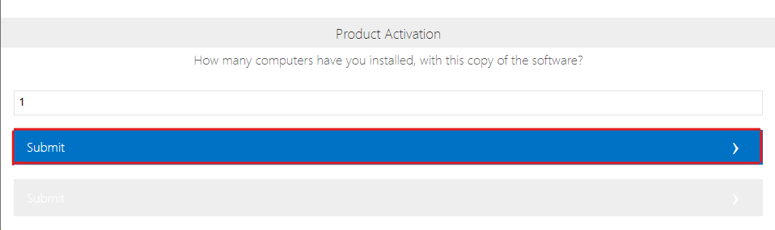
8. You should get the confirmation ID from the site.  
   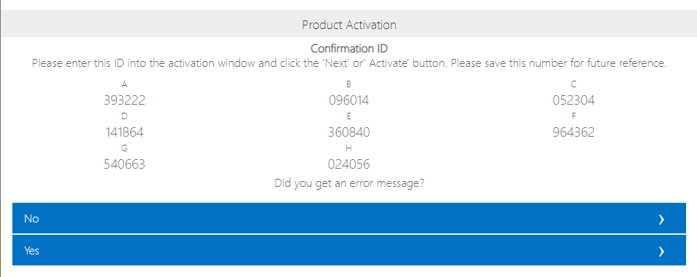  
   Enter this in the Vista Activation Wizard and click next.  
   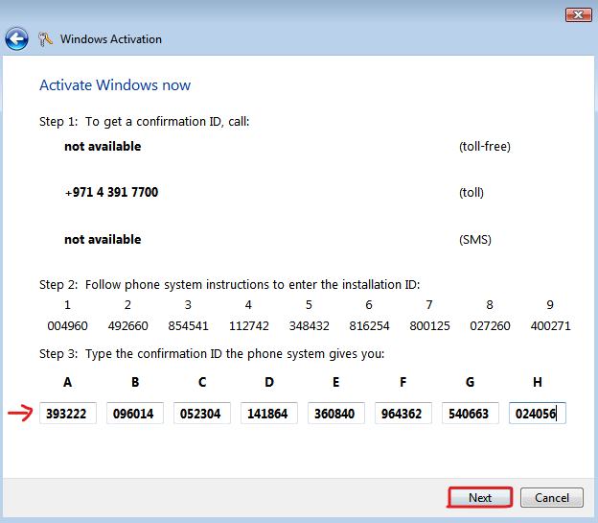
9. Now, Windows Vista Home Premium(64 bit or 32 bit) should be activated!  
   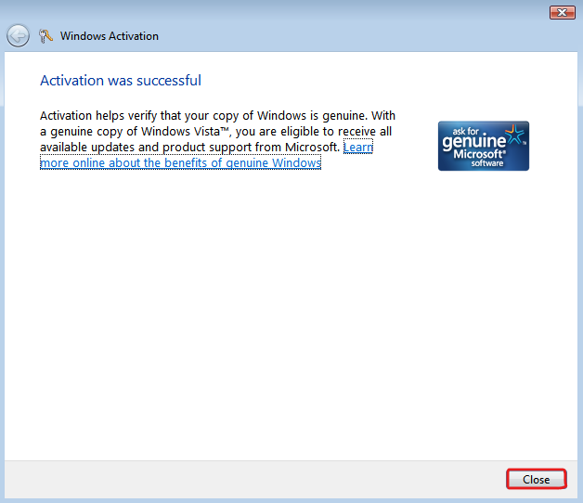  
   You can then click on the close button to exit the Activation Wizard. As for the online site you still have open, you can safely close the tab without any side effects.
10. Enjoy your activated Vista Home Premium VM! 😁